Heaven's light is our guide
Rajshahi University of Engineering & Technology

Department of Computer Science & Engineering



Sessional (Lab Report)-03

Course Name : Data Communication Sessional
Course Code : CSE 3204
Experiment No : 03
Experiment Name : Data Transmission Using Frequency Division Multiplexing
(FDM).
Date of Experiment : 15 Nov, 2025
Date of Submission : 03 Jan, 2026

Submitted by:  Roll Name  2103061 Md. Mushfiqur Rahman  2103062 Md. Rraf Hasan  2103063 Md. Raiyan Haque Ashwas  2103064 Md. Asad-Al-Adil  2103065 Md. Morakib Hossain  2103066 Md. Akibul Hasan | Submitted to:  Shyla Afroge  Associate Professor  Department of Computer Science and Engineering, RUET

Experiment name:
Data Transmission Using Frequency Division Multiplexing (FDM).

Objective:
- To demonstrate the method of transmitting multiple signals using Frequency Division Multiplexing (FDM)
- Analyze the signals during modulation and demodulation processes.

Theory:
Frequency Division Multiplexing (FDM) is a technique for sending multiple signals over a single communication path at the same time. It works by giving each signal its own unique frequency slot within the total available bandwidth, ensuring the signals don't interfere with each other.
Commonly used in telephone networks and radio, this experiment aims to demonstrate the FDM process. We will modulate several signals onto different frequencies, combine them into one, and transmit it. The receiver will then filter and separate this combined signal to recover the individual, original signals.

Required Equipment:
1. Function Generator:
- Produces sinusoidal, square, or triangular signals of various frequencies and amplitudes. Used for input and carrier signal generation.

2. Oscilloscope:
- Visualizes waveforms to analyze input, modulated, transmitted, and demodulated signals.

3. FDM Modulator Circuit:
- Mixer: Combines input and carrier signals to create modulated outputs.
- Bandpass Filter: Allows signals within specific frequency bands to pass.
- Amplifier: Boosts the strength of modulated signals for transmission.

4. FDM Demodulator Circuit:
- Mixer: Separates modulated signals from carrier waves.
- Low-Pass Filter: Recovers the original input signals.
- Amplifier: Strengthens the recovered signals.

5. Connecting Wires:
- Provide necessary electrical connections.

6. Power Supply:
- Supplies required voltage to the circuit components.

Pin connections:
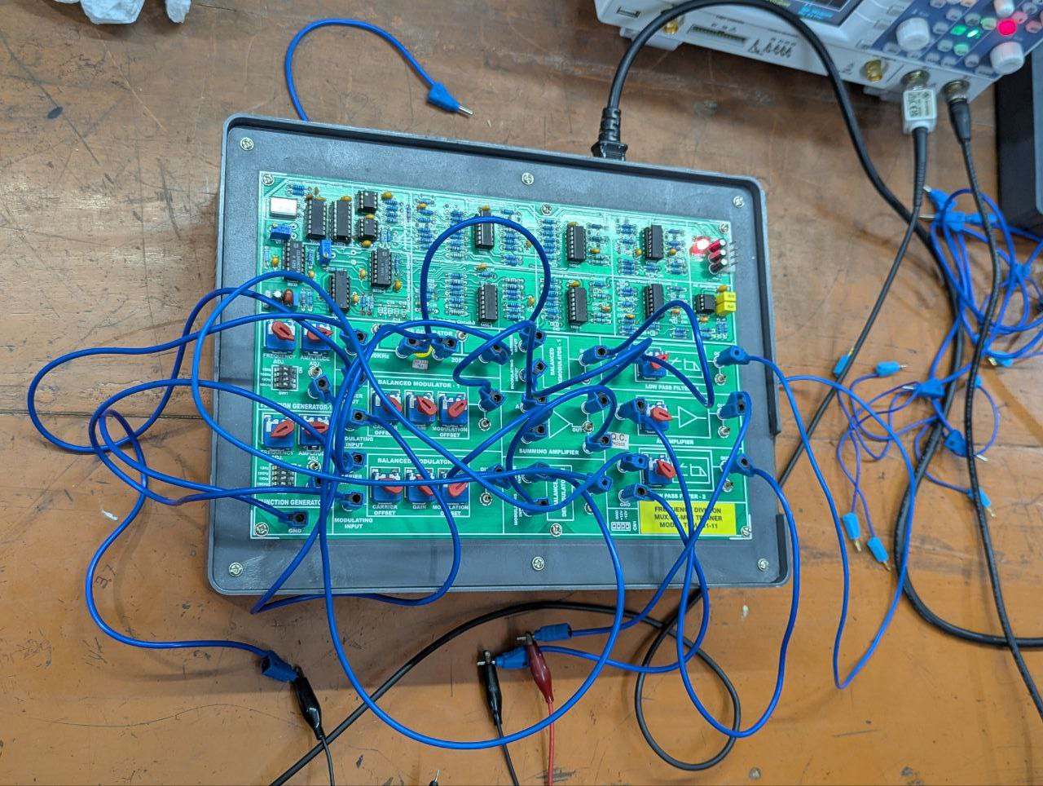

Procedure:

Signal Generation:
- Using the function generator, two sinusoidal signals of distinct frequencies were created. These signals were set to specific amplitudes and frequencies suitable for the experiment.
- To ensure accuracy, the generated signals were displayed and verified on the oscilloscope. Adjustments were made if necessary to match the desired configurations.

FDM Modulation:
- Each signal was paired with a unique carrier frequency and fed into the FDM modulator circuit. Proper attention was given to wiring connections for the mixers, bandpass filters, and amplifiers.
- Observing the oscilloscope, the modulated signals displayed characteristics of their respective carriers embedded with the input signal information.

Multiplexing and Transmission:
- The modulated signals were combined into a single composite signal using a multiplexing process. This signal represented the combination of all individual transmissions.
- The composite signal was transmitted through a designated communication channel. Throughout this stage, the oscilloscope was used to ensure that the integrity of the transmitted signal was maintained.

FDM Demodulation:
- At the receiving end, the composite signal was directed into the demodulator circuit. This step involved separating the signals by their respective carrier frequencies.
- Each demodulated signal underwent processing through low-pass filters and amplifiers to recover the original waveforms.

Signal Observation:
- Reconstructed signals were compared side by side with the original input signals. The oscilloscope displayed the demodulated signals, confirming their fidelity to the initial configurations.

Output:

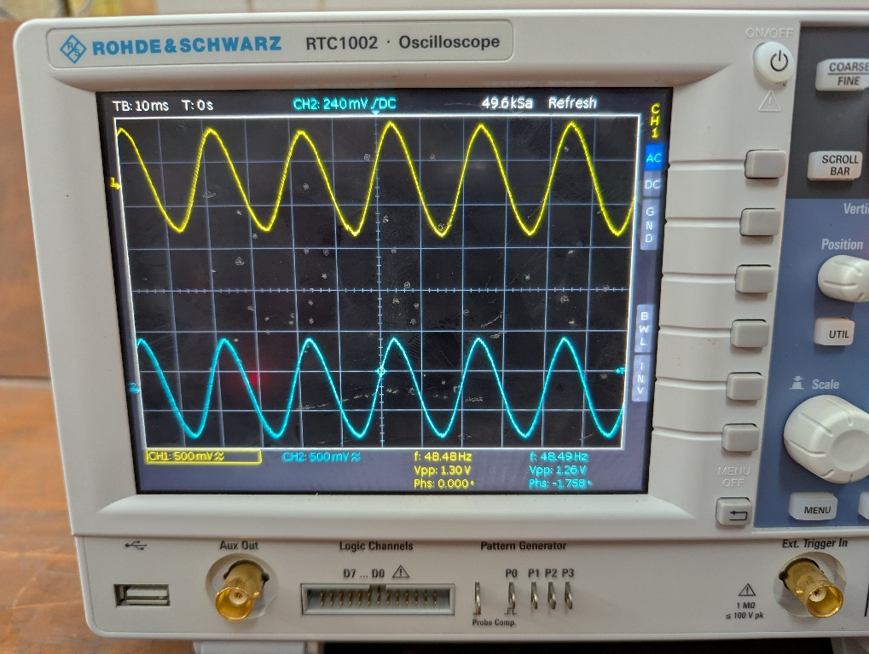
Fig-01: Input Signal
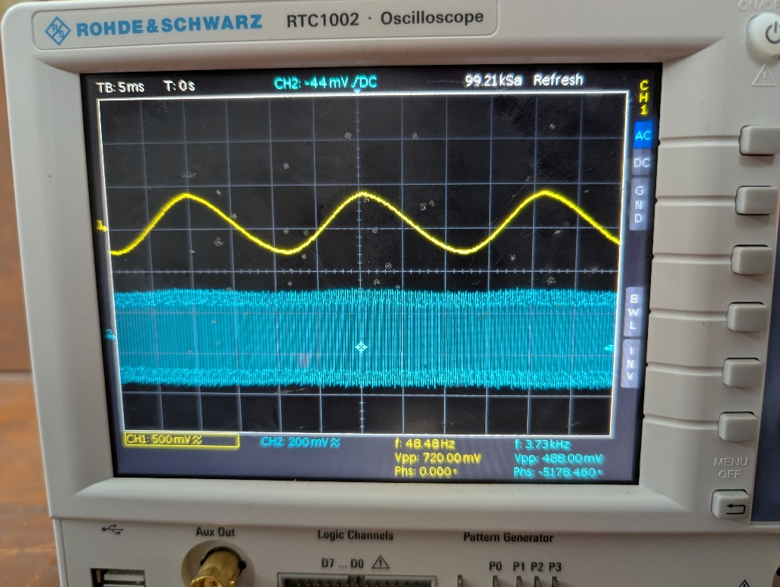
Fig-02: Modulated Signal

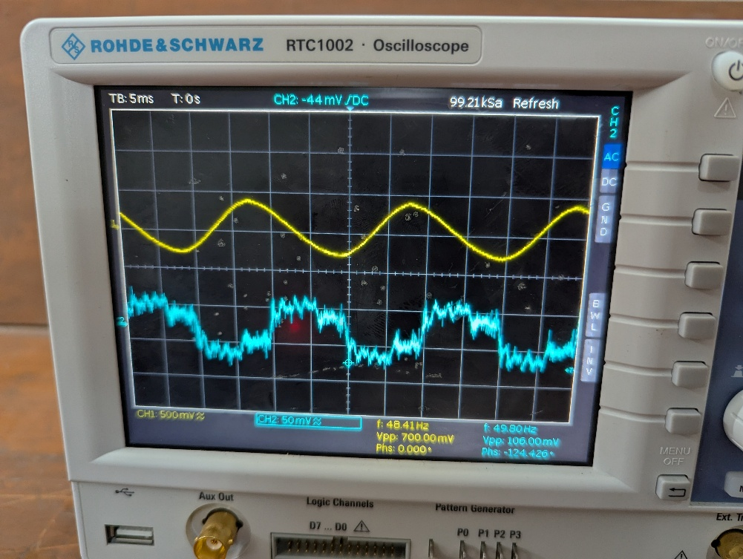
Fig-03: Demodulated Signal without Amplification

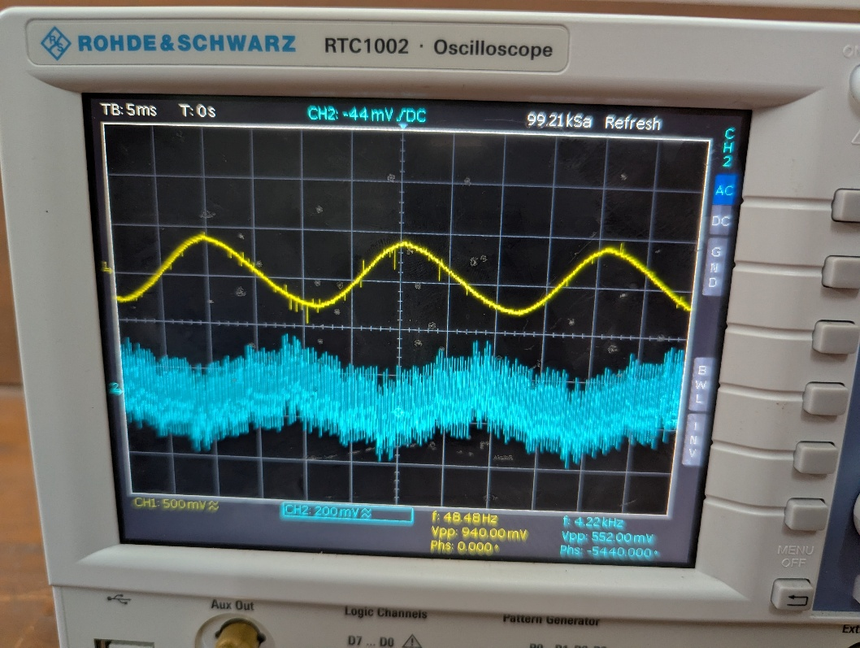
Fig-04: Demodulated Signal with Amplification

Precautions:
- Preventing Overmodulation
- Set Frequencies Correctly
- Properly adjust the probes of the oscilloscope to get nearly appropriate result.
- Do Auto-set after every connection for updating the result.

Conclusion:
- This experiment demonstrated the essential principles of Frequency Division Multiplexing (FDM), an efficient technique for transmitting multiple signals simultaneously.
- During the process, each input signal was modulated with its carrier frequency, creating distinct frequency bands for each signal.
- These modulated signals were successfully multiplexed into a composite waveform, which retained the integrity of the individual signals even during transmission.

